**BÀI TẬP: ỨNG DỤNG CHAT TCP/UDP**

**MSSV: 22521385**

**HỌ TÊN: LẠI QUAN THIÊN**

**I. ỨNG DỤNG CHAT TCP**

**1. Ảnh Màn Hình**

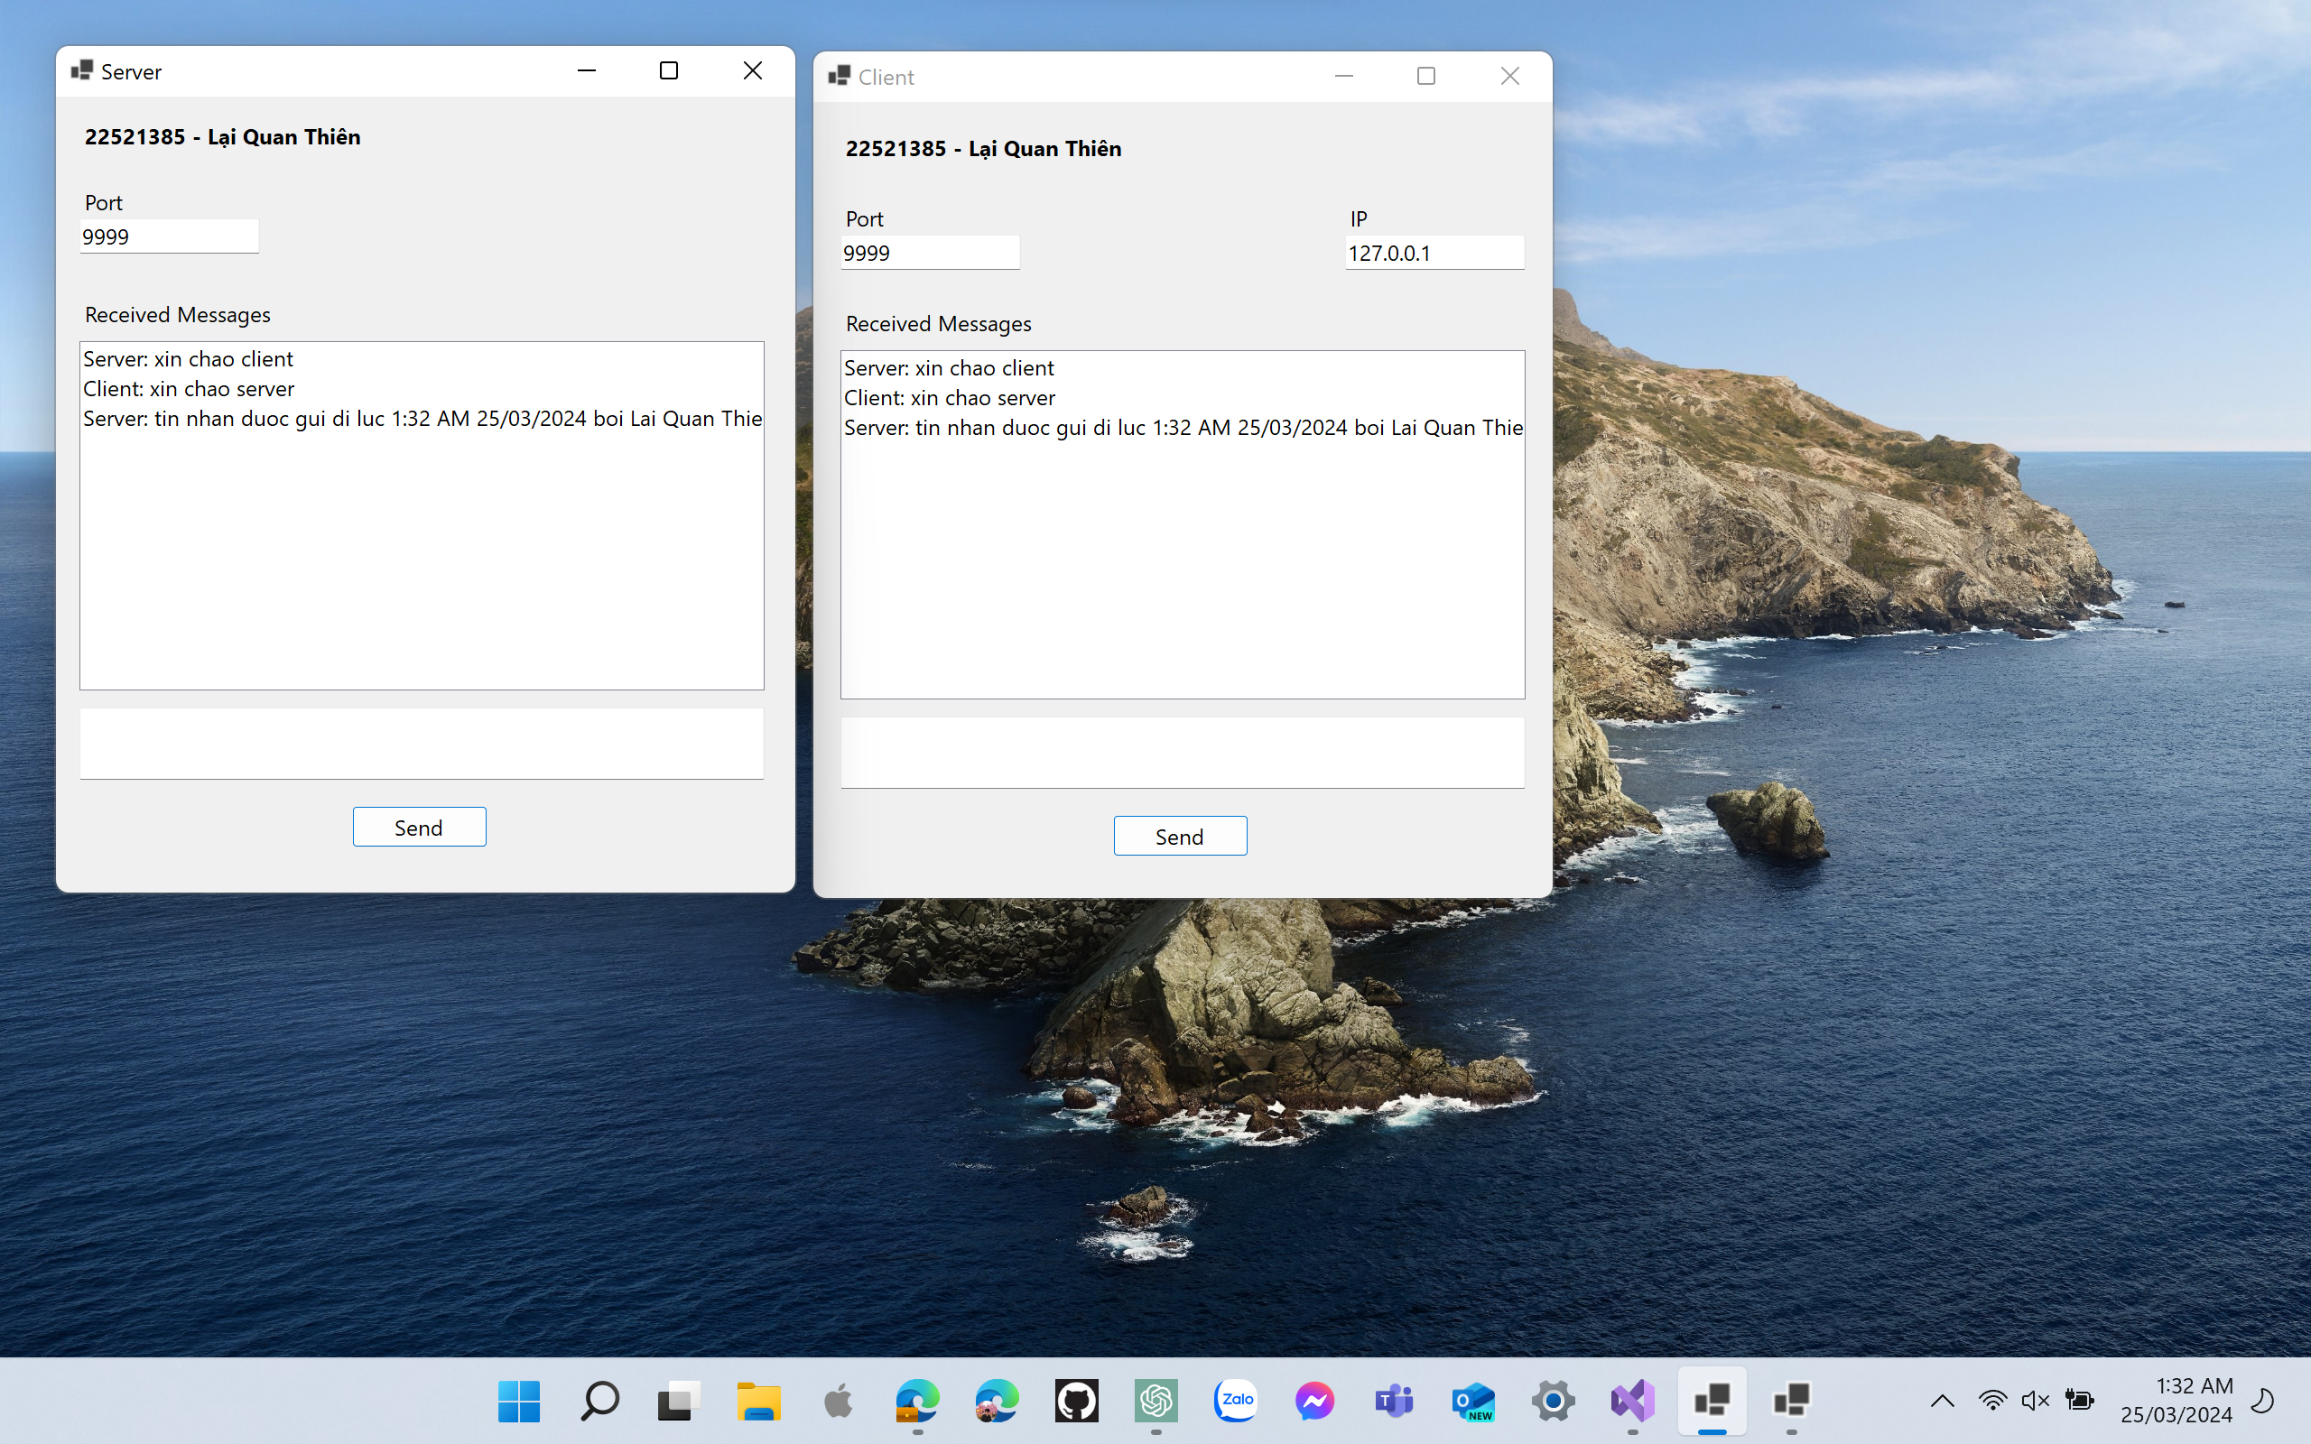

**2. Source Code:**

**a. Client:**

|  |
| --- |
| using System.Net.Sockets;  using System.Net;  using System.Text;  using System.Threading;  using System.IO;  namespace Cilent_TCP  {  public partial class Form1 : Form  {  public Form1()  {  InitializeComponent();  Control.CheckForIllegalCrossThreadCalls = false;  Connect();  }  IPEndPoint ipe;  TcpClient tcpclient;  Stream stream;  private void btnSend_Click(object sender, EventArgs e)  {  Send();  }  void Connect()  {  IPAddress ip = IPAddress.Parse(txbIp.Text);  int port = int.Parse(txbPort.Text);  ipe = new IPEndPoint(ip, port);  tcpclient = new TcpClient();  tcpclient.Connect(ipe);  stream = tcpclient.GetStream();  Thread recv = new Thread(Receive);  recv.IsBackground = true;  recv.Start();  }  void Send()  {  byte[] data = Encoding.UTF8.GetBytes(txbMess.Text);  stream.Write(data, 0, data.Length);  Addmessage("Client: " + txbMess.Text);  txbMess.Text = "";  }  void Receive()  {  while (true)  {  byte[] recv = new byte[1024];  stream.Read(recv, 0, recv.Length);  string s = Encoding.UTF8.GetString(recv);  Addmessage("Server: " + s);  }  }  void Addmessage(string mess)  {  lvMess.Items.Add(mess);  }  }  } |

**b. Server:**

|  |
| --- |
| using System.Net.Sockets;  using System.Net;  using System.Text;  using System.Threading;  namespace Server_TCP  {  public partial class Form1 : Form  {  public Form1()  {  InitializeComponent();  Control.CheckForIllegalCrossThreadCalls = false;  Connect();  }  IPEndPoint ipe;  Socket client;  TcpListener tcplisten;  private void btnSend_Click(object sender, EventArgs e)  {  Send(client);  }  void Connect()  {  ipe = new IPEndPoint(IPAddress.Any, 9999);  tcplisten = new TcpListener(ipe);  Thread thread = new Thread(  () => {  while (true)  {  tcplisten.Start();  client = tcplisten.AcceptSocket();  Thread rec = new Thread(Receive);  rec.IsBackground = true;  rec.Start(client);  }  });  thread.IsBackground = true;  thread.Start();  }  void Send(Socket client)  {  byte[] data = Encoding.UTF8.GetBytes(txbMess.Text);  client.Send(data);  Addmessage("Server: " + txbMess.Text);  txbMess.Text = "";  }  void Receive(object obj)  {  while (true)  {  Socket client = obj as Socket;  byte[] recv = new byte[1024];  client.Receive(recv);  string s = Encoding.UTF8.GetString(recv);  Addmessage("Client: " + s);  }  }  void Addmessage(string mess)  {  lvMess.Items.Add(mess);  }  }  } |

**II. ỨNG DỤNG CHAT UDP**

**1. Ảnh Màn Hình**

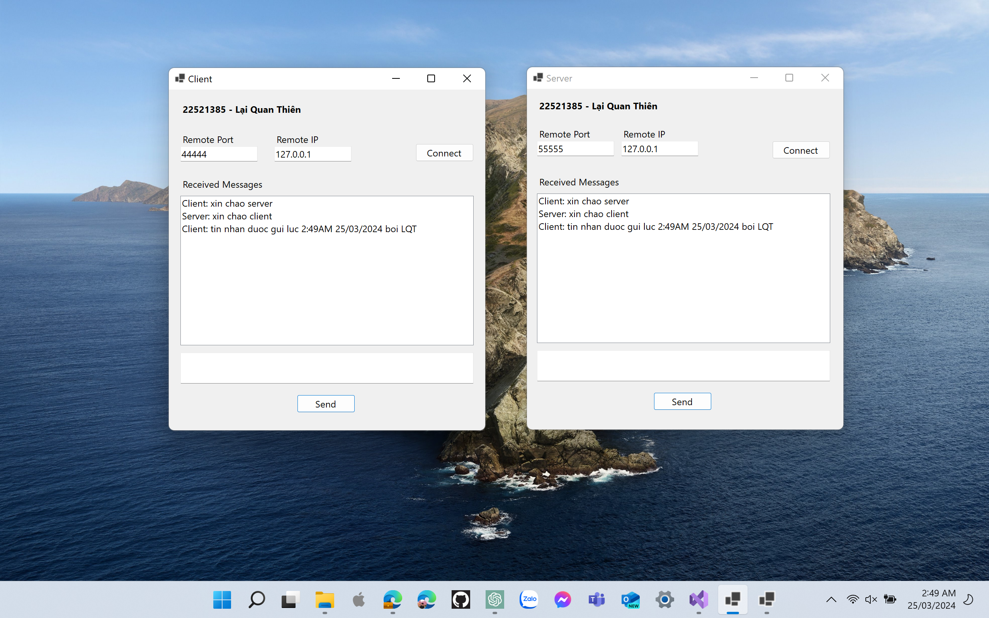

**2. Source Code:**

**a. Client:**

|  |
| --- |
| using System.Net.Sockets;  using System.Net;  using System.Text;  using System.Threading;  using System.IO;  using System.Windows.Forms;  using static System.Windows.Forms.VisualStyles.VisualStyleElement;  namespace Cilent_TCP  {  public partial class Client : Form  {  public Client()  {  InitializeComponent();  Control.CheckForIllegalCrossThreadCalls = false;  }  UdpClient client;  IPEndPoint remoteIP;  int port = 55555;  private void btnConnect_Click(object sender, EventArgs e)  {  int remotePort = int.Parse(txbPort.Text);  client = new UdpClient(port);  remoteIP = new IPEndPoint(IPAddress.Parse(txbIp.Text), remotePort);  client.BeginReceive(new AsyncCallback(onReceive), client);  }  private void onReceive(IAsyncResult AR)  {  byte[] buff = client.EndReceive(AR, ref remoteIP);  client.BeginReceive(new AsyncCallback(onReceive), client);  string mess = Encoding.ASCII.GetString(buff);  AddMessage("Server: " + mess);  }  private void btnSend_Click(object sender, EventArgs e)  {  client.Connect(remoteIP);  client.Send(Encoding.ASCII.GetBytes(txbMess.Text), txbMess.Text.Length);  AddMessage("Client: " + txbMess.Text);  txbMess.Clear();  }  void AddMessage(string str)  {  lvMess.Items.Add(str);  }  }  } |

**b. Server:**

|  |
| --- |
| using System.Net.Sockets;  using System.Net;  using System.Text;  using System.Threading;  namespace Server_TCP  {  public partial class Server : Form  {  public Server()  {  InitializeComponent();  Control.CheckForIllegalCrossThreadCalls = false;  }  UdpClient server;  IPEndPoint remoteIP;  int port = 44444;  private void btnConnect_Click(object sender, EventArgs e)  {  int remotePort = int.Parse(txbPort.Text);  server = new UdpClient(port);  remoteIP = new IPEndPoint(IPAddress.Parse(txbPort.Text), remotePort);  server.BeginReceive(new AsyncCallback(onReceive), server);  }  private void btnSend_Click(object sender, EventArgs e)  {  server.Connect(remoteIP);  server.Send(Encoding.ASCII.GetBytes(txbMess.Text), txbMess.Text.Length);  AddMessage("Server: " + txbMess.Text);  txbMess.Clear();  }  private void onReceive(IAsyncResult AR)  {  byte[] buff = server.EndReceive(AR, ref remoteIP);  server.BeginReceive(new AsyncCallback(onReceive), server);  string mess = Encoding.ASCII.GetString(buff);  AddMessage("Client: " + mess);  }    void AddMessage(string str)  {  lvMess.Items.Add(str);  }  }  } |